**STROKE PREDICTION WEB-APP DEPLOYMENT VIA STREAMLIT**

PROJECT BY:

| **NAME** | **UID** | **ROLL NO.** |
| --- | --- | --- |
| VERONICA MARIA DSOUZA | 229005 | 04 |
| OLIVIA AMBROSE | 229016 | 15 |
| HRISHITA SURESH | 229032 | 24 |

SYNOPSIS:

WHAT DOES OUR WEB APPLICATION EXACTLY DO?

→ Our web application accepts user inputs about various health related queries such as the age, smoking status, bmi, etc., of an individual and then with the help of our machine learning model built via PYTHON, it makes a prediction about how likely an individual is to have a stroke in the near future.

FIRSTLY WE TAKE A LOOK AT OUR ML MODEL BUILDING:

→ STEP 1: importing necessary inbuilt packages and loading the dataset:

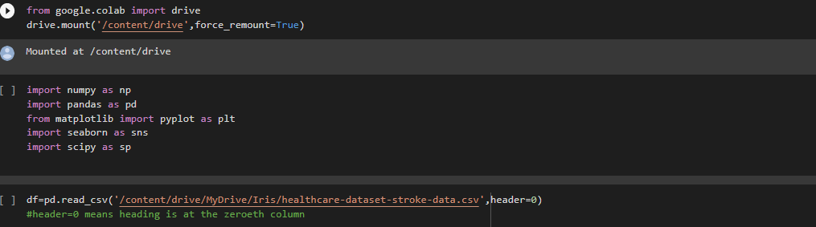

→ STEP 2: Let us learn about our dataset before we get into pre-processing:

The data set contains 5110 rows and 12 columns i.e., 5110 observations and 10 columns that are used as features excluding id and 1 column used as the target i.e., stroke

Information about the columns:

1. gender: gives the gender of the individual
2. age: gives the age of the individual
3. hypertension: describes whether the individual has hypertension or not. 0 for no and 1 for yes.
4. heart_disease: describes whether the individual has heart disease or not. 0 for no and 1 for yes.
5. ever_married: describes whether the individual has ever been married or not.
6. work_type: describes the work environment of the individual
7. Residence_type: describes the area where the individual resides
8. avg_glucose_level: gives the average blood glucose level of the individual
9. bmi: gives the BMI of individual
10. smoking_status: describes whether a person has smoked or not
11. stroke: describes whether the individual has suffered a stroke or not. 0 for no and 1 for yes.

STEP 3: Snippets of preprocessing and feature engineering:

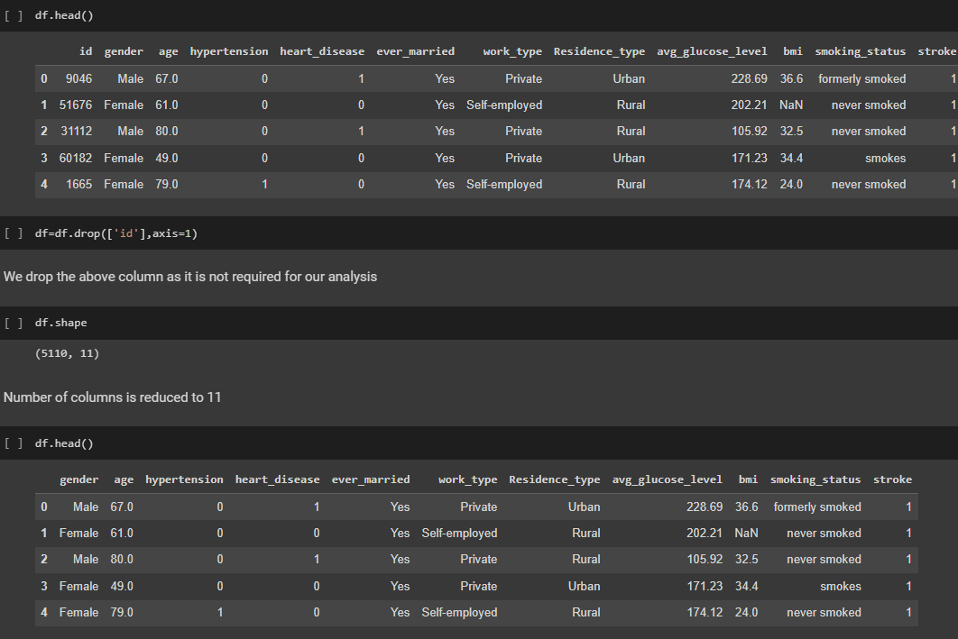

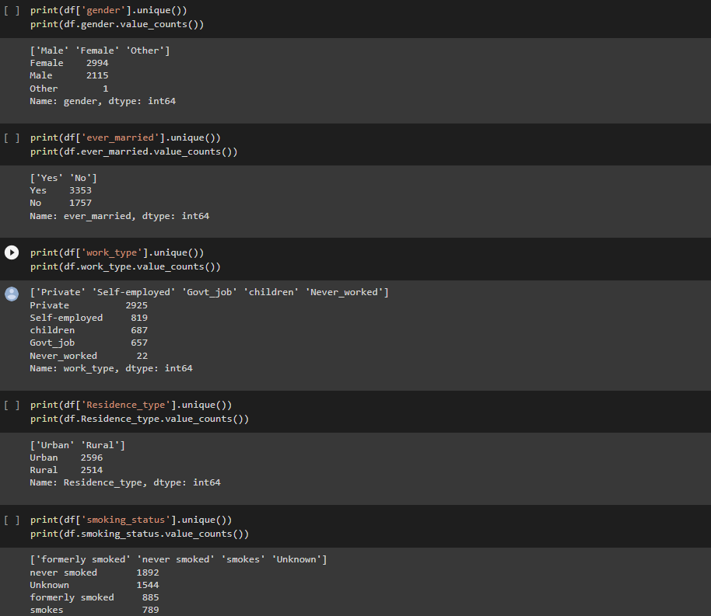

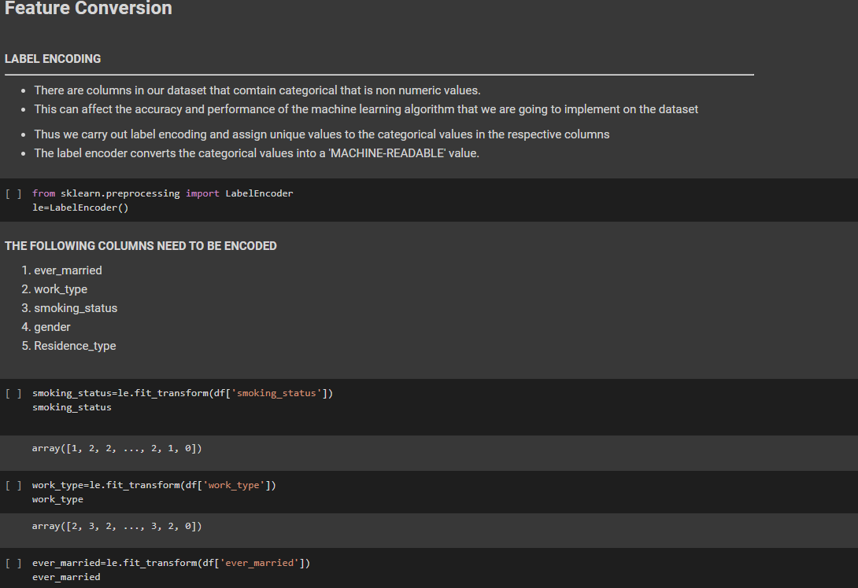

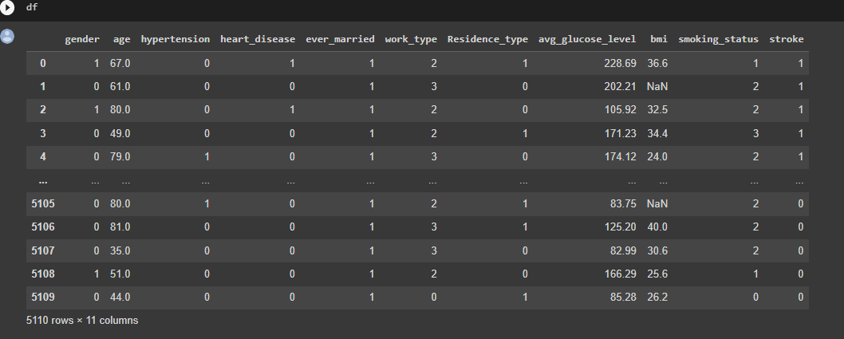

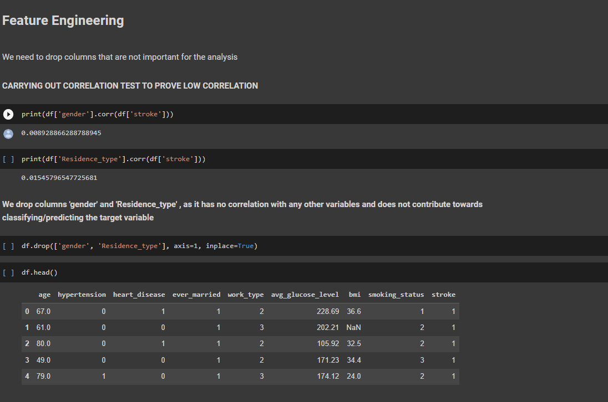

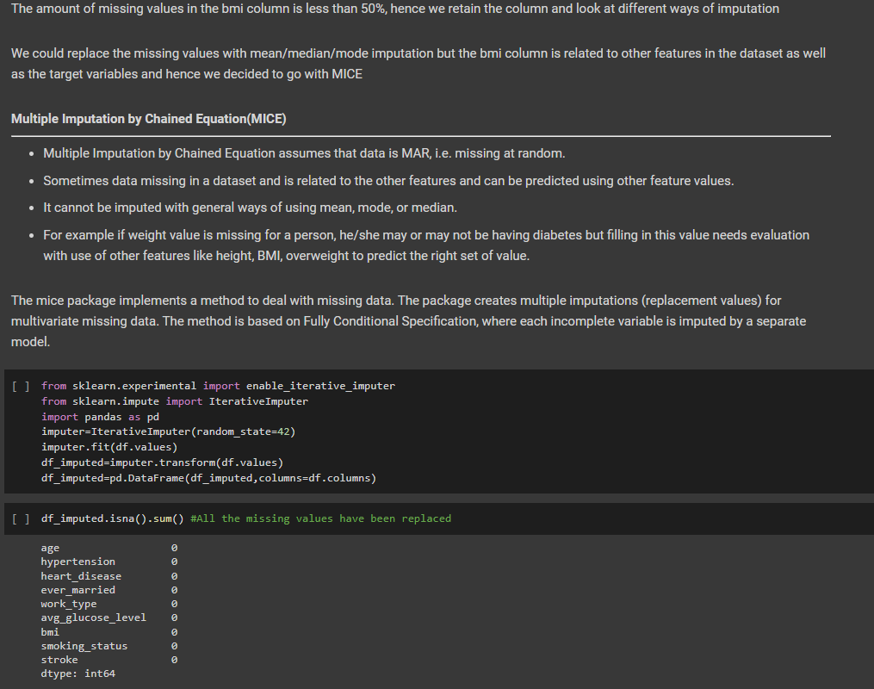

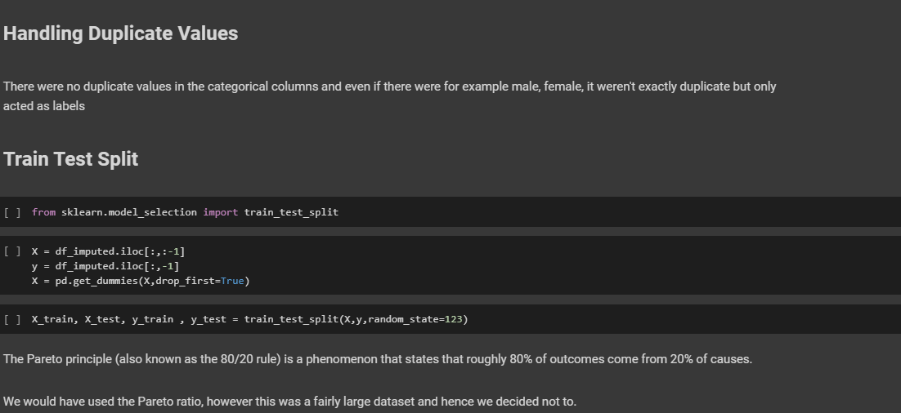

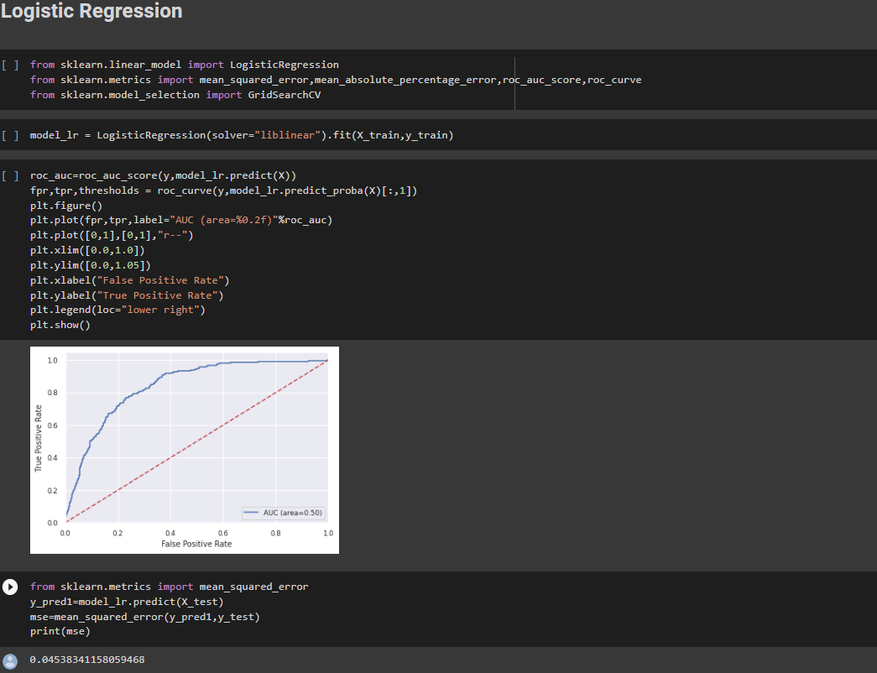

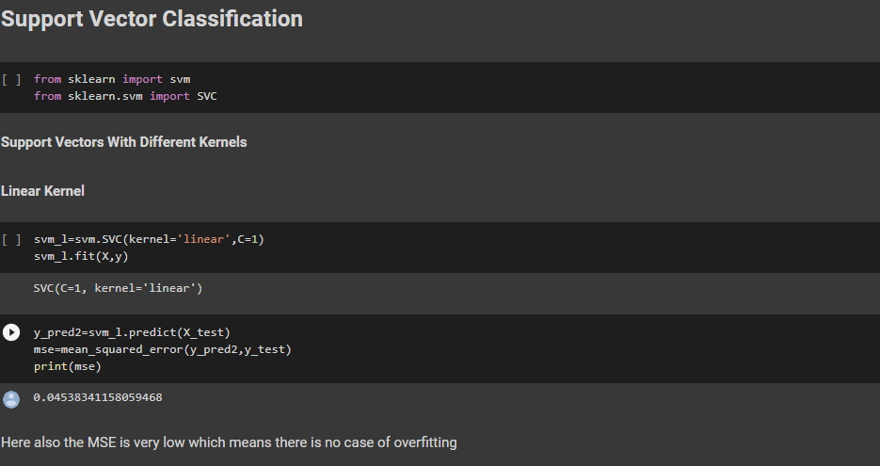

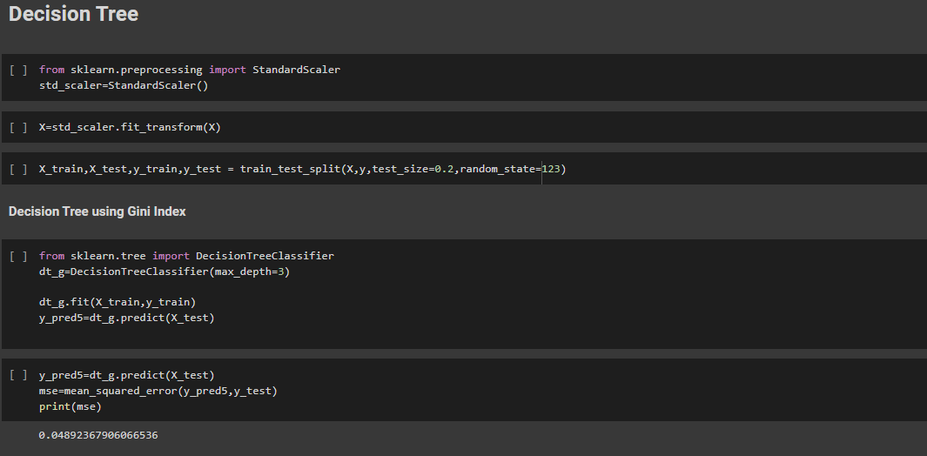

**FINDING FEATURE IMPORTANCE FROM THE DATASET:**

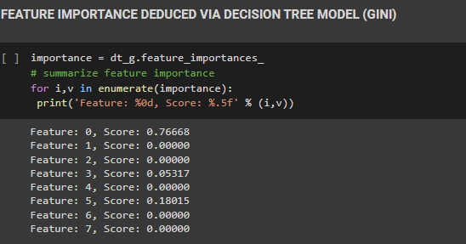



DECISION TREE PLOTTED:

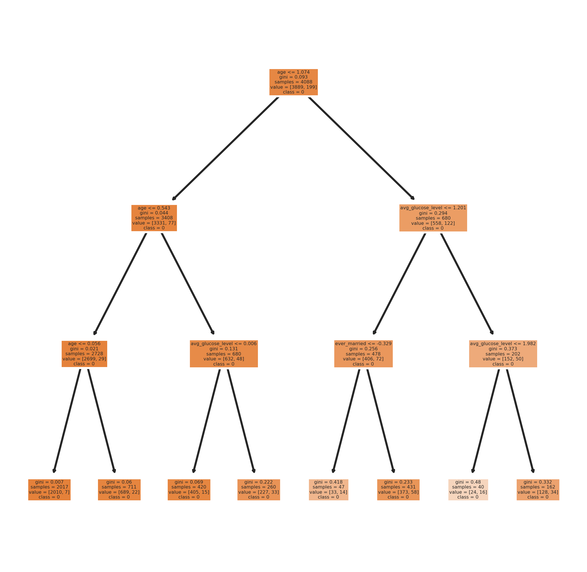

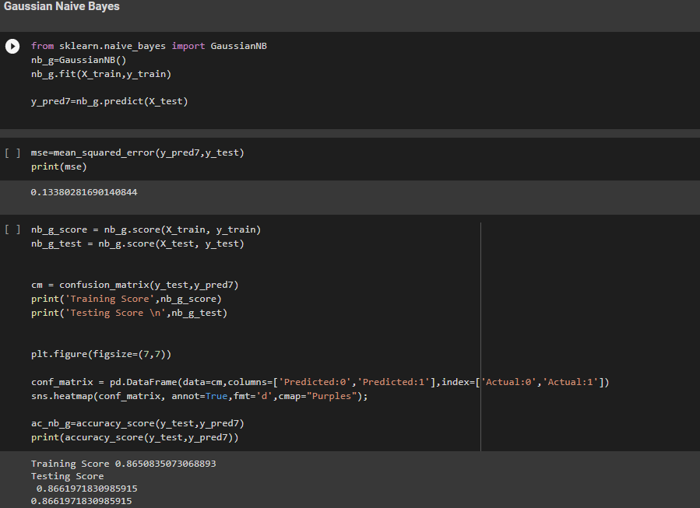

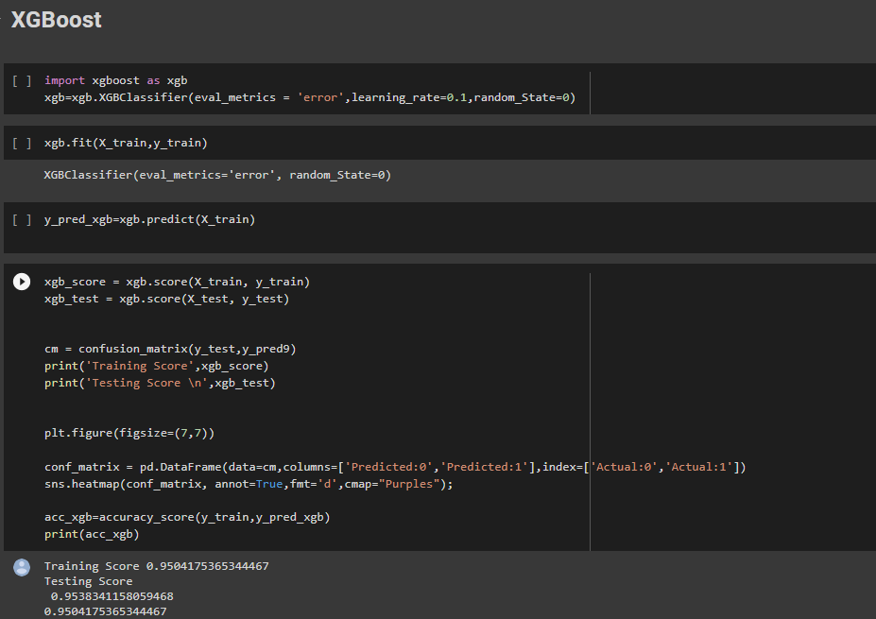

ACCURACY SCORE COMPARISON GRAPH:

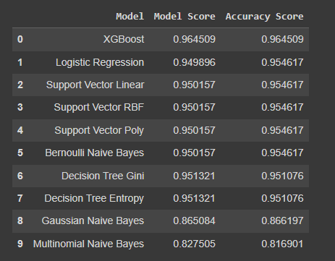

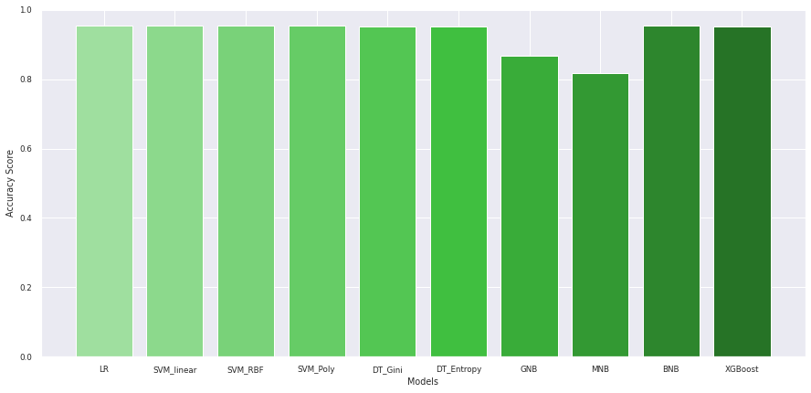

CONCLUSION:

We gain the best accuracy score from the LOGISTIC REGRESSION model. .

Thus we use it to build our prediction model.

1. First we pickle our model:

What is a pickle?

Pickle is a generic object serialization module that can be used for serializing and deserializing objects. While it’s most commonly associated with saving and reloading trained machine learning models, it can actually be used on any kind of object. Here’s how you can use Pickle to save a trained model to a file and reload it to obtain predictions.

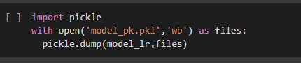

Here, model_lr is our “logistic regression” model.

The raw pickle file:

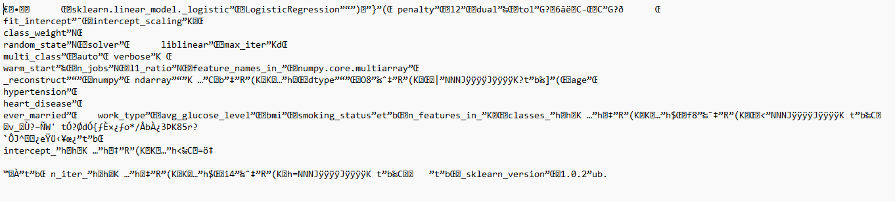

1. We use streamlit to create a UI for the model we built:

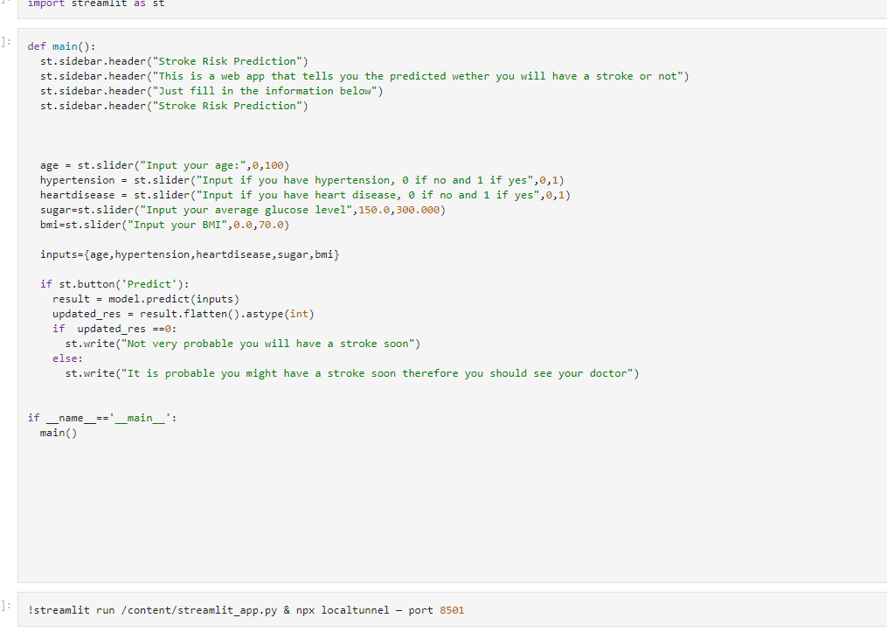

1. We created a Git repository with all the necessary files:

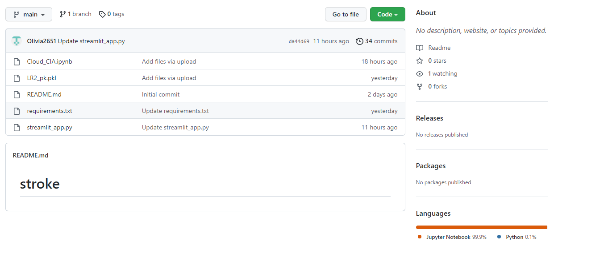

1. We then deployed our app on Streamlit using the repository:

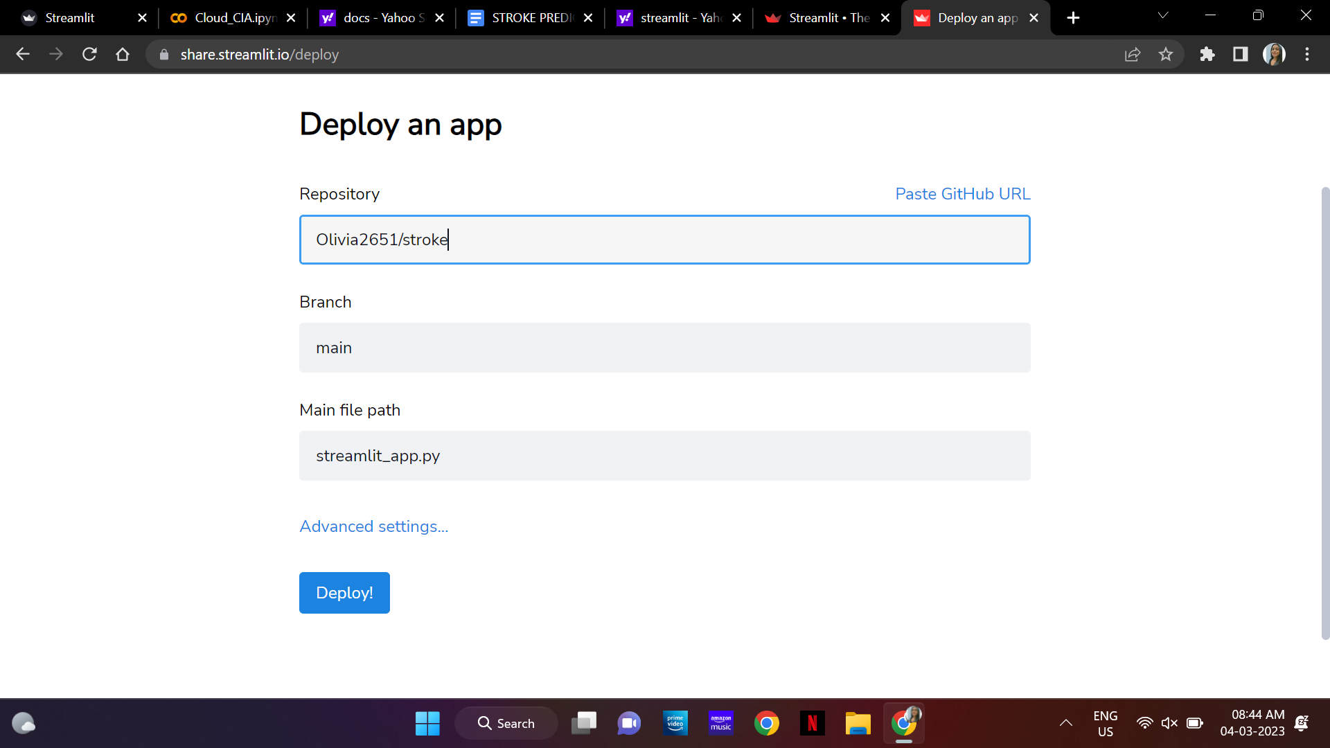

1. Streamlit UI (desktop):

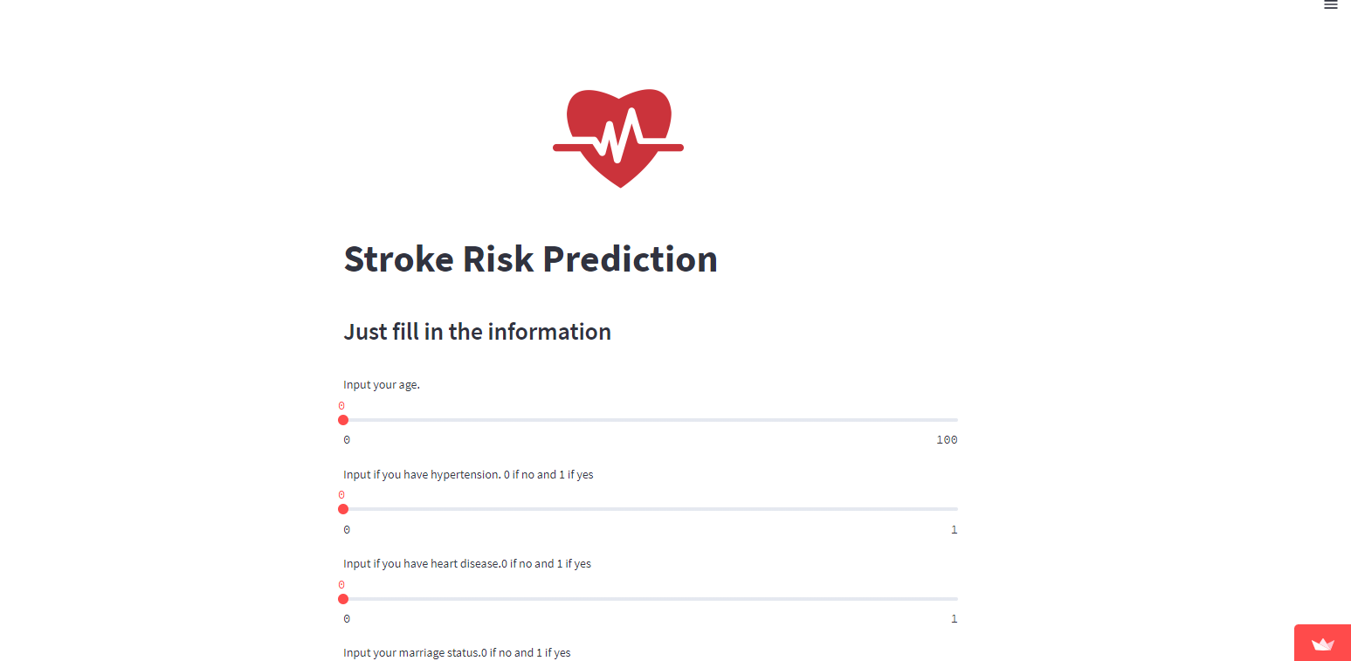

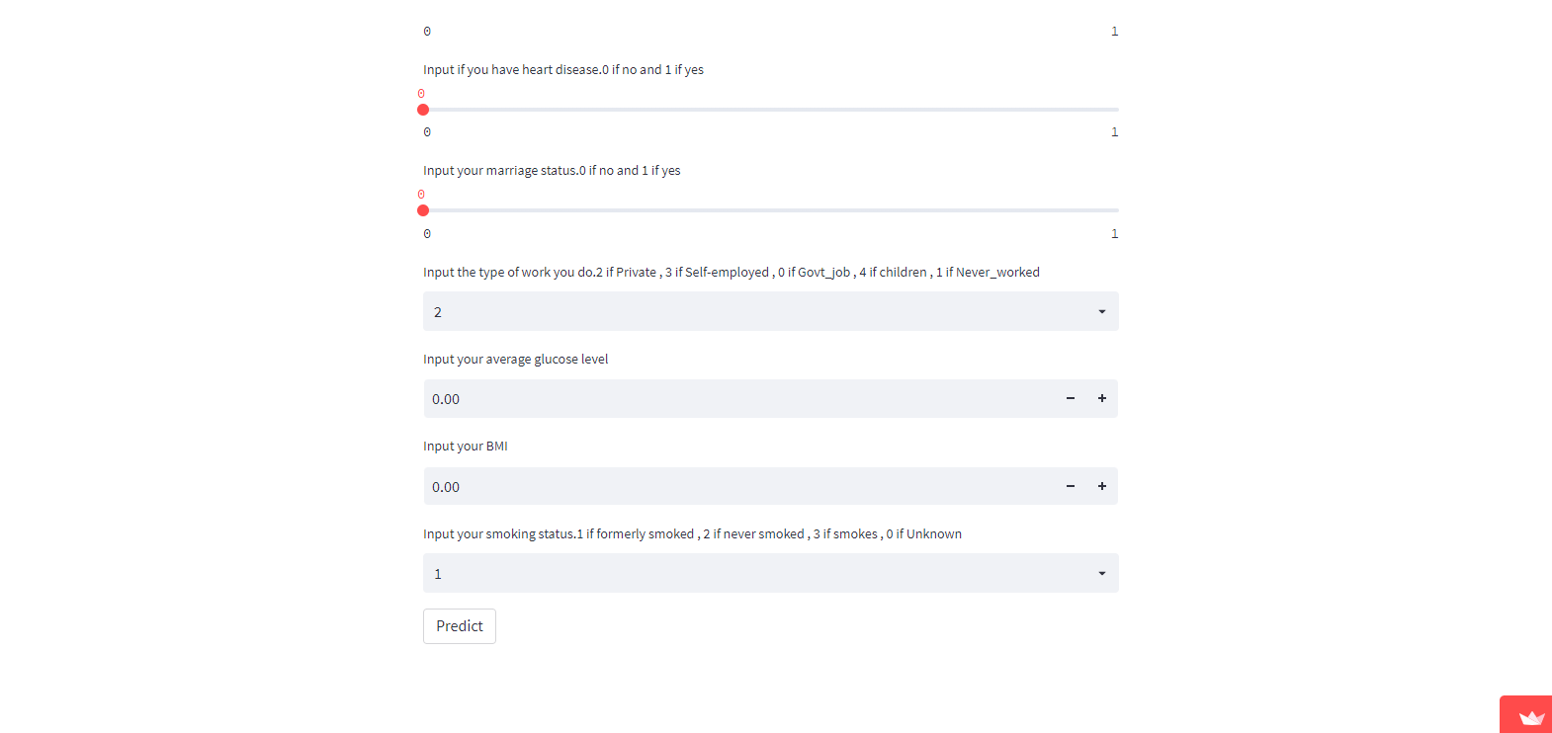

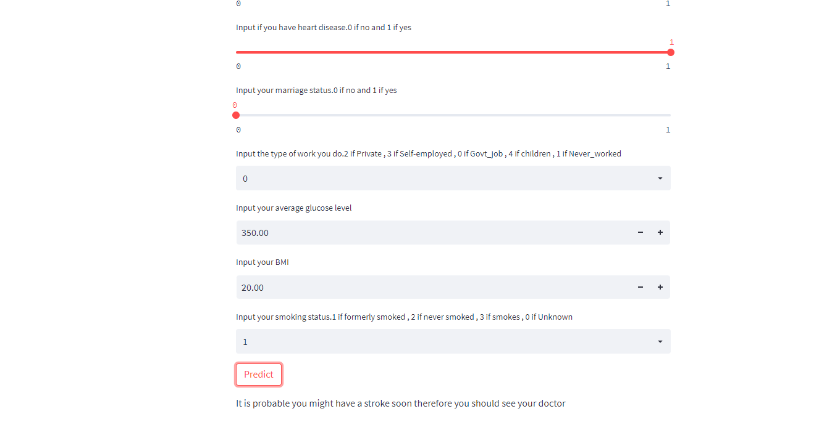

1. Streamlit UI (phone):

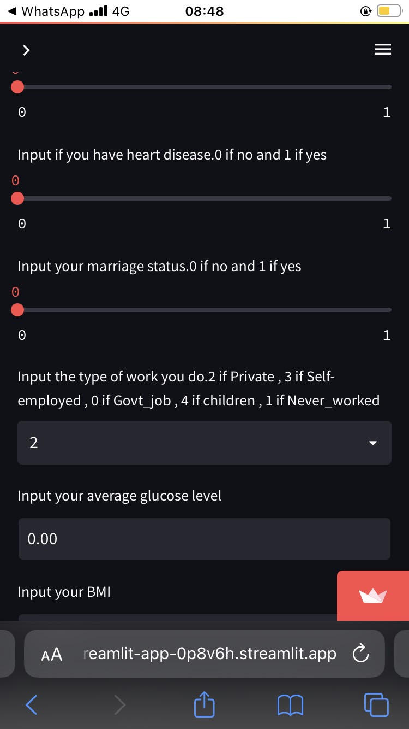

Github repository link: <https://github.com/Olivia2651/stroke.git>

Streamlit application link :<https://olivia2651-stroke-streamlit-app-0p8v6h.streamlit.app/>